
FINAL YEAR GROUP PROJECT
Ephemeral Anonymous Messaging System(EAMS)
Group Members:
1. Athman Ibrahim BSCCS/2022/48631
2. Joseph Kihamba BSCCS/2022/33117
3. Mohamed Ali Bore BSCCS/2023/45387
4. Derek Wango BSCCS/2022/59177
5. David Muchai BSCCS/2023/39100

Supervisor: Md. Elena Mwai

The design and implementation of an ephemeral zero-trust communication protocol using a stateless relay architecture

DECLARATION
We declare that this project report entitled "GhostRelay: A Secure Peer-to-Peer Messaging Platform with Rust-Based Cryptography and Go Relay Architecture" is our original work and has not been submitted to any other institution for the award of any degree, diploma, or certificate.
All sources of information used in this project have been duly acknowledged through references.

Group Member Name | Registration Number | Signature
- Athman Ibrahim | BSCCS/2022/48631 | _______________________
- Joseph Kihamba | BSCCS/2022/33117 | _______________________
- Mohamed Ali Bore | BSCCS/2023/45387 | _______________________
- Derek Wango | BSCCS/2022/59177 | _______________________
- David Muchai | BSCCS/2023/39100 | _______________________

Date: _______________________

Supervisor's Declaration
This project has been submitted for examination with my approval as the university supervisor.
Supervisor Name: _______________________
Signature: _______________________
Date: _______________________

DEDICATION
This project is dedicated to our families for their unwavering support, encouragement, and sacrifice throughout our academic journey. Their belief in our ability to pursue the passion for technology has been the driving force behind our determination to complete this work.
We also dedicate this project to every aspiring software engineer and cybersecurity enthusiast who believes that privacy is a fundamental human right. It is our hope that GhostRelay serves as a reminder that secure communication should not be considered a luxury, but rather a necessity in today's digital world.
Finally, we dedicate this work to everyone striving to build safer and more trustworthy technologies that protect users rather than exploit them.

ACKNOWLEDGEMENTS
The successful completion of this project would not have been possible without the guidance, encouragement, and support of many individuals.
First and foremost, we express our sincere gratitude to Almighty God for granting us the strength, wisdom, good health, and perseverance throughout the development of this project.
We would also like to express our heartfelt appreciation to our project supervisor for the continuous guidance, constructive criticism, and valuable suggestions provided throughout the project. Their professional advice helped shape the direction of this work and greatly improved the quality of the final system.
Special appreciation goes to the lecturers within the School of Computing and Information Technology at Mount Kenya University for providing the academic knowledge and technical foundation that enabled the successful implementation of this project. Their dedication to teaching has greatly contributed to our growth as software developers and cybersecurity practitioners.
We are sincerely grateful to our families for their unwavering encouragement, patience, financial support, and belief in our abilities throughout our university education. Their sacrifices have been instrumental in helping us achieve this milestone.
Finally, we acknowledge the global open-source software community whose publicly available libraries, frameworks, documentation, and research resources made it possible to develop GhostRelay. Technologies such as React Native, Rust, Go, Kotlin, Expo, Android Studio, and numerous open-source packages significantly accelerated the development process while providing reliable and modern software development practices.

ABSTRACT
The rapid growth of digital communication has significantly increased concerns regarding user privacy, data confidentiality, and secure message delivery. Although many messaging applications implement end-to-end encryption, a considerable number still rely on centralized infrastructures that retain user metadata, expose communication patterns, or require extensive personal information during registration. These limitations continue to present privacy risks for individuals seeking anonymous and secure communication.
This project presents GhostRelay, a secure cross-platform messaging application designed to prioritize privacy through modern cryptographic techniques and a lightweight relay architecture. The system combines a React Native mobile application, a Rust-based cryptographic engine, and a Go relay server to create a messaging platform capable of securely exchanging encrypted messages while minimizing the amount of information stored on the server. Unlike conventional messaging platforms, GhostRelay focuses on ensuring that the relay server acts only as a temporary transport mechanism without gaining access to plaintext message content.
The mobile client was developed using React Native to provide a modern, responsive, and platform-independent user interface. Cryptographic operations including identity generation, key management, encryption, and decryption are delegated to a Rust security core, selected for its memory safety, performance, and resistance to common programming vulnerabilities. Communication between users is facilitated through a lightweight Go-based relay server responsible for temporarily storing encrypted payloads until they are retrieved by the intended recipient.
The development process followed an iterative software engineering approach in which system requirements were identified, architectural components were designed, user interfaces were implemented, native security modules were integrated, and communication services were gradually connected into a unified application. Particular emphasis was placed on modular software architecture, allowing each component of the system to evolve independently while maintaining secure interactions through clearly defined interfaces.
The resulting system demonstrates that combining Rust-based cryptography with a lightweight relay infrastructure provides a practical approach to secure mobile messaging. GhostRelay establishes a foundation for future enhancements including anonymous relay routing, decentralized node discovery, post-quantum cryptographic algorithms, ephemeral identities, multi-device synchronization, and anonymous communication networks. The project contributes to ongoing research in secure mobile communication by illustrating how modern programming languages and secure architectural principles can be combined to develop privacy-first communication platforms suitable for contemporary cybersecurity requirements.

Contents
DECLARATION 2
Supervisor's Declaration 3
DEDICATION 4
ACKNOWLEDGEMENTS 5
ABSTRACT 6
CHAPTER ONE 9
INTRODUCTION 9
1.1 Background of the Study 9
1.2 Statement of the Problem 11
1.3 Objectives of the Study 12
1.3.1 General Objective 12
1.3.2 Specific Objectives 12
1.4 Research Questions 13
1.5 Significance of the Study 14
1.6 Scope of the Study 14
CHAPTER TWO 15
LITERATURE REVIEW 15
2.0 Introduction 15
2.1 Evolution of Digital Communication Systems 16
2.2 Secure Communication Systems 17
2.3 End-to-End Encryption 17
2.4 Metadata Privacy 18
2.5 Public Key Cryptography 18
2.6 Relay Servers 19
2.7 Rust in Mobile Security 19
2.8 Go Programming Language for Networking 20
2.9 React Native for Cross-Platform Mobile Development 20
2.10 Existing Secure Messaging Applications 21
2.11 Research Gap 21
2.12 Chapter Summary 22
CHAPTER THREE 22
METHODOLOGY 22
3.1 Introduction 22
3.2 Research Methodology 23
3.3 Software Development Methodology 23
3.4 System Architecture 24
3.5 System Design 27
3.6 Development Environment 28
3.7 Technologies Used 28
3.8 Module Design 29
3.9 Secure Message Flow 30
3.10 Security Design 31
3.11 Testing Methodology 31
3.12 Chapter Summary 32
CHAPTER FOUR 33
SYSTEM IMPLEMENTATION AND TESTING 33
4.1 Introduction 33
4.2 Development Environment 35
4.3 Implementation of the Mobile Application 37
4.4 Implementation of the Rust Security Core 46
4.5 Kotlin Native Integration 49
4.6 System Testing and Validation 51
4.7 Results and Discussion 53
4.8 Security Evaluation 54
4.9 Challenges Encountered 56
4.10 Chapter Summary 56
CHAPTER FIVE 57
TESTING, EVALUATION, CONCLUSION AND RECOMMENDATIONS 57
5.1 Introduction 58
5.2 System Testing 58
5.3 Testing Environment 59
5.4 Functional Testing Results 59
5.5 Integration Testing Results 60
5.6 Security Evaluation 61
5.7 Challenges Encountered 61
5.8 Project Limitations 62
CHAPTER SIX 62
CONCLUSION AND RECOMMENDATIONS 62
6.1 Conclusion 63
6.2 Recommendations 63
REFERENCES 64

CHAPTER ONE

INTRODUCTION

1.1 Background of the Study
The rapid advancement of digital communication technologies has transformed the manner in which individuals, organizations, and governments exchange information. Mobile messaging applications have become an integral part of modern communication by providing instant, convenient, and cost-effective interaction regardless of geographical location. Applications such as WhatsApp, Telegram, Signal, Messenger, and many others have significantly reduced communication barriers while increasing global connectivity. Despite these advancements, the increasing dependence on internet-based communication has introduced numerous cybersecurity challenges, particularly regarding data privacy, message confidentiality, identity protection, and resistance against surveillance.
Conventional messaging applications often depend on centralized cloud infrastructures where user data, metadata, authentication services, and message routing are managed by a central authority. Although many modern applications implement encryption, a considerable amount of metadata including sender identities, recipient information, timestamps, device identifiers, IP addresses, and connection history remains accessible to service providers. Such metadata may be sufficient to reconstruct communication patterns, social relationships, organizational structures, and user behavior without necessarily decrypting message content.
Recent developments in cyber warfare, digital surveillance, corporate data harvesting, and unauthorized interception of communication have demonstrated that protecting only message content is no longer sufficient. Secure communication systems must also minimize metadata exposure, strengthen identity verification, and reduce centralized trust assumptions. These concerns have become increasingly important for journalists, human rights organizations, government institutions, cybersecurity professionals, businesses handling confidential information, and individuals who value personal privacy.
The emergence of decentralized networking technologies has provided an alternative approach to secure communication. Instead of relying on centralized infrastructures, decentralized relay systems distribute communication responsibilities among independent relay nodes while allowing cryptographic operations to occur entirely on user devices. This significantly minimizes the attack surface available to malicious actors while reducing opportunities for mass surveillance.
Modern cryptographic algorithms have also experienced tremendous advancement. Elliptic Curve Cryptography (ECC), Ed25519 digital signatures, X25519 key exchange mechanisms, ChaCha20 encryption, and authenticated encryption algorithms now enable efficient end-to-end encryption even on resource-constrained mobile devices. These technologies make it possible to develop secure communication systems capable of providing confidentiality, integrity, authenticity, forward secrecy, and resistance against message tampering without introducing excessive computational overhead.
GhostRelay is developed within this technological context as a secure communication platform that combines modern cryptographic principles with decentralized message routing. Rather than storing sensitive information on centralized servers, GhostRelay performs cryptographic operations locally on the user's mobile device using a Rust-based security core while utilizing a lightweight Go relay server exclusively for temporary message forwarding. The relay server does not possess the cryptographic keys required to decrypt user messages, thereby ensuring that message confidentiality remains entirely under user control.
Unlike conventional messaging applications, GhostRelay separates the system into independent architectural components. The React Native mobile application provides the graphical user interface responsible for user interaction. The Rust security core performs cryptographic operations including identity generation, encryption, decryption, key management, digital signatures, and secure message handling. The Go relay server functions solely as an encrypted message transport mechanism, forwarding ciphertext between communicating devices without accessing its plaintext contents. Kotlin integration provides the Android-native bridge required for packaging the mobile application and communicating between the React Native interface and the underlying Rust library.
This modular architecture increases maintainability, improves security isolation, and enables each component to evolve independently without affecting the overall system. Such separation of responsibilities represents modern secure software engineering practices while maintaining scalability for future expansion.
The development of GhostRelay therefore contributes toward ongoing efforts in secure mobile communication by demonstrating how multiple programming languages and technologies can be integrated into a unified architecture capable of delivering privacy-preserving communication while maintaining usability, portability, and extensibility.

1.2 Statement of the Problem
The widespread adoption of mobile messaging platforms has significantly improved digital communication; however, it has simultaneously introduced substantial privacy and security concerns. Existing messaging systems frequently rely on centralized infrastructures that maintain considerable control over user authentication, message routing, contact management, and storage services. Although end-to-end encryption has become increasingly common, centralized architectures continue to expose valuable metadata that may reveal sensitive information regarding user interactions, communication frequency, device locations, and social relationships.
In many systems, encryption keys are managed using mechanisms that still require trust in centralized infrastructure for authentication, account recovery, or device synchronization. Such dependencies increase the attack surface available to cybercriminals and create potential vulnerabilities through server compromise, insider threats, government surveillance, or infrastructure failure.
Another challenge involves the increasing sophistication of cyber attacks targeting mobile communication systems. Threat actors continuously exploit weaknesses including man-in-the-middle attacks, replay attacks, message interception, impersonation, unauthorized access, malicious relay servers, and compromised authentication mechanisms. While many commercial messaging applications continuously improve their security features, users remain dependent on proprietary infrastructures whose internal implementations are not always transparent or independently verifiable.
Additionally, existing messaging applications often combine multiple responsibilities including user authentication, cloud storage, notification services, media synchronization, backup management, analytics, and message routing within a single centralized ecosystem. Such tightly coupled architectures increase system complexity while creating single points of failure capable of affecting millions of users simultaneously.
For cybersecurity research and educational purposes, there remains a need for practical implementations demonstrating how secure communication systems can be designed using modern cryptographic techniques while minimizing centralized trust assumptions. There is limited availability of open architectures illustrating how independent security components including cryptographic engines, mobile user interfaces, and relay services can cooperate while maintaining strict separation of responsibilities.
GhostRelay addresses these limitations by introducing a modular secure messaging platform where cryptographic processing occurs entirely within a locally executing Rust security engine while encrypted messages are transmitted through a lightweight Go relay server that lacks the capability to decrypt transmitted data. The project seeks to demonstrate that secure communication can be achieved through careful architectural separation, modern cryptographic design, and decentralized message forwarding without sacrificing usability on contemporary mobile devices.

1.3 Objectives of the Study

1.3.1 General Objective
The general objective of this project is to design, develop, and evaluate GhostRelay, a secure mobile messaging platform that integrates modern cryptographic techniques, decentralized relay communication, and mobile application technologies to provide confidential, authenticated, and privacy-preserving communication.

1.3.2 Specific Objectives
The specific objectives of this study are to develop a React Native mobile application that provides an intuitive and responsive user interface for secure messaging while supporting Android deployment. The project further seeks to integrate a Rust-based cryptographic engine responsible for secure identity generation, public-private key management, encryption, decryption, digital signatures, and message authentication without exposing sensitive cryptographic operations to the application layer.
Another objective is to implement a lightweight Go relay server responsible solely for secure encrypted message forwarding without storing plaintext communication or possessing decryption capabilities. The project also aims to establish secure communication between the mobile application and the relay server through authenticated network protocols capable of transmitting encrypted payloads efficiently.
The study further intends to evaluate the architectural separation between the user interface, cryptographic engine, and relay infrastructure in order to demonstrate improved maintainability, modularity, and security isolation. Finally, the project seeks to provide a practical educational implementation illustrating how multiple programming languages including React Native, Rust, Go, and Kotlin can be integrated into a single secure mobile communication platform.

1.4 Research Questions
The study seeks to answer several research questions concerning secure mobile communication systems. The primary question investigates how a decentralized relay architecture can improve user privacy compared to conventional centralized messaging systems. Another question examines whether performing cryptographic operations entirely on client devices can effectively reduce trust requirements placed upon communication servers.
The study also seeks to determine how multiple programming languages with different responsibilities can be integrated into a cohesive mobile application without compromising maintainability or security. Furthermore, the research investigates whether a lightweight relay server that only forwards encrypted data can adequately support secure communication without requiring access to message contents.
Finally, the study evaluates whether combining React Native, Rust, Go, and Kotlin provides an efficient software architecture capable of supporting future expansion while maintaining acceptable performance on Android mobile devices.

1.5 Significance of the Study
The significance of GhostRelay extends across several domains including cybersecurity research, software engineering, mobile application development, cryptographic system design, and computer science education.
For cybersecurity researchers, the project demonstrates practical implementation of modern cryptographic principles within a production-oriented software architecture. The separation between cryptographic processing and communication infrastructure provides an excellent case study for secure software design and threat reduction.
For software developers, GhostRelay illustrates how heterogeneous technologies including React Native, Rust, Go, and Kotlin can be integrated into a modular architecture while maintaining clear separation of concerns. This architectural approach promotes maintainability, extensibility, and easier debugging compared to monolithic implementations.
For academic institutions, the project provides an educational reference demonstrating practical application of concepts taught within computer science curricula including cryptography, secure software engineering, networking, distributed systems, mobile application development, and systems programming.
For organizations handling sensitive information, GhostRelay demonstrates an alternative communication architecture that minimizes centralized trust assumptions while reducing exposure of confidential data to intermediary infrastructure.
Finally, the project contributes to the growing body of knowledge surrounding privacy-preserving communication technologies by presenting a practical implementation of decentralized encrypted messaging suitable for further research and future enhancement.

1.6 Scope of the Study
This study focuses on the design and implementation of GhostRelay as an Android-based secure messaging application. The project encompasses four primary architectural components including the React Native mobile application, the Rust cryptographic security core, the Go relay server, and Kotlin integration required for Android packaging and native module communication.
The research concentrates on secure identity generation, encrypted message transmission, relay communication, cryptographic integration, mobile user interface development, and system architecture. The implementation targets Android devices and does not include native support for iOS platforms during the current development phase.
The relay server is intentionally designed to function solely as a message forwarding service and therefore excludes permanent cloud storage, user analytics, centralized authentication databases, multimedia synchronization, or account recovery services. Similarly, the project does not attempt to replace commercial messaging platforms but rather demonstrates an educational and research-oriented secure communication architecture emphasizing privacy, modularity, and cryptographic security.

CHAPTER TWO

LITERATURE REVIEW

2.0 Introduction
The rapid evolution of digital communication has fundamentally transformed the manner in which individuals, organizations, and governments exchange information. Mobile messaging applications have become the primary medium for both personal and professional communication, replacing traditional methods such as Short Message Service (SMS), electronic mail, and voice communication in many parts of the world. This transition has introduced unprecedented convenience by enabling instant communication across geographical boundaries while simultaneously increasing the demand for secure methods of transmitting sensitive information.
Despite these technological advancements, the increasing reliance on internet-based communication platforms has introduced numerous cybersecurity challenges. Data breaches, unauthorized surveillance, identity theft, metadata collection, and unauthorized interception of communications have become significant concerns among users and cybersecurity professionals alike. Modern messaging platforms often rely on centralized cloud infrastructures that, while offering scalability and reliability, introduce single points of trust and potential targets for cyberattacks. Even when message contents are encrypted, metadata such as communication frequency, timestamps, device information, and user identities may still be collected and analyzed.
The growing awareness of digital privacy has accelerated research into secure messaging architectures capable of protecting not only message confidentiality but also user anonymity and communication metadata. Cryptographic algorithms have evolved considerably over the past several decades, moving from simple symmetric encryption schemes to sophisticated public-key infrastructures, digital signatures, authenticated encryption mechanisms, and zero-knowledge protocols. At the same time, software engineering practices have shifted toward memory-safe programming languages and modular system architectures capable of reducing software vulnerabilities while improving maintainability.
GhostRelay was conceived within this context as a privacy-oriented messaging platform that minimizes trust in centralized infrastructure while maximizing client-side security. Rather than depending solely on server-side protection mechanisms, GhostRelay adopts a layered security architecture in which cryptographic operations are executed locally within the user's device through a Rust-based security core, while a lightweight relay server developed in Go functions primarily as a temporary encrypted message transport mechanism. This architectural separation minimizes the exposure of plaintext information and reduces the attack surface available to adversaries.
This chapter reviews existing literature related to secure messaging systems, modern cryptographic techniques, relay-based communication architectures, programming languages used in secure systems development, mobile application frameworks, and current cybersecurity practices. The discussion identifies limitations within existing communication platforms and demonstrates how the design principles adopted in GhostRelay address many of these shortcomings.

2.1 Evolution of Digital Communication Systems
This chapter presents an extensive review of existing knowledge, technologies, methodologies and research related to secure communication systems and privacy-preserving messaging applications. The review establishes the theoretical and technical foundation upon which GhostRelay was developed. Various concepts including encrypted communication, metadata privacy, decentralized messaging architectures, cryptographic protocols, relay servers, identity management, mobile security and cross-platform application development are examined. Existing secure messaging applications are also analyzed to identify their strengths and limitations. The findings from this literature review highlight the existing gaps within secure communication technologies and justify the need for GhostRelay as a privacy-first communication platform.

2.2 Secure Communication Systems
Secure communication refers to the process of exchanging information while ensuring that unauthorized individuals cannot access, modify or intercept transmitted data. The primary objective of secure communication is to preserve the confidentiality, integrity and authenticity of information during transmission over potentially insecure networks such as the Internet.
Traditional communication systems mainly rely on transport layer encryption such as HTTPS or TLS. While these protocols protect data during transmission, they do not prevent service providers from accessing message contents since decryption usually occurs on centralized servers before messages reach recipients. Consequently, users must place complete trust in the service provider to safeguard their private information.
Modern secure communication systems have evolved towards end-to-end encryption where messages are encrypted before leaving the sender's device and remain encrypted until decrypted by the intended recipient. Under this architecture, intermediary servers merely relay encrypted data without possessing the cryptographic keys required to decrypt it. This significantly minimizes trust assumptions and greatly improves user privacy.
GhostRelay adopts this modern approach by ensuring that encryption operations occur locally on the user's mobile device through its Rust Security Core. The relay server is intentionally designed to function solely as a transport layer without accessing plaintext messages, thereby reducing potential attack surfaces and enhancing user privacy.

2.3 End-to-End Encryption
End-to-End Encryption (E2EE) is regarded as one of the most important security mechanisms used in modern communication systems. Under this security model, only communicating endpoints possess the necessary cryptographic keys to encrypt and decrypt messages.
Unlike traditional encryption models where servers temporarily decrypt messages before forwarding them, end-to-end encryption eliminates server-side access completely. Even if communication servers are compromised, intercepted messages remain unreadable without the corresponding private keys.
Several widely used messaging applications, including Signal and WhatsApp, implement end-to-end encryption using variations of the Signal Protocol. Although highly secure, these systems still expose significant metadata such as user identities, timestamps, contact relationships and message routing information.
GhostRelay extends beyond traditional end-to-end encryption by separating identity generation, encryption and message transport into independent architectural components. The encryption keys never leave the user's device, while the relay server merely stores encrypted packets until they are collected by the intended recipient.
This architectural separation minimizes trust requirements and significantly strengthens privacy compared to centralized messaging systems.

2.4 Metadata Privacy
Although end-to-end encryption protects message contents, communication metadata often remains exposed. Metadata refers to information describing communication rather than the communication itself. Examples include sender identities, recipient identities, timestamps, device identifiers, IP addresses and communication frequency.
Research has shown that metadata alone can reveal sensitive behavioural patterns including personal relationships, daily routines, geographical movements and organizational structures. Intelligence agencies and cybercriminals frequently exploit metadata to build detailed user profiles without ever accessing message contents.
Many existing messaging applications continue collecting large volumes of metadata to facilitate contact discovery, synchronization, targeted advertising and user analytics.
GhostRelay addresses this challenge by minimizing metadata collection throughout the communication process. Instead of relying on centralized user accounts tied to phone numbers or email addresses, GhostRelay generates anonymous cryptographic identities locally using the Rust Security Core. Communication occurs using cryptographic fingerprints rather than personally identifiable information, thereby significantly reducing metadata exposure.

2.5 Public Key Cryptography
Public key cryptography forms the backbone of modern secure communication systems. Unlike symmetric encryption where both communicating parties share the same secret key, public key cryptography uses mathematically related key pairs consisting of a public key and a private key.
The public key may be distributed openly without compromising security, while the private key remains confidential on the owner's device. Messages encrypted using a recipient's public key can only be decrypted using the corresponding private key.
This mechanism solves the key distribution problem that has historically challenged secure communication systems.
GhostRelay employs asymmetric cryptography during identity creation. Every user generates a unique cryptographic identity locally on their device. The generated public key becomes the user's communication identity while the private key remains securely stored within the application. This approach enables secure communication without centralized identity providers.

2.6 Relay Servers
A relay server acts as an intermediary responsible for temporarily storing and forwarding encrypted messages between communicating parties. Unlike traditional messaging servers that often process message contents, relay servers in privacy-focused architectures should remain oblivious to the information they transport.
The concept of store-and-forward communication has existed for decades in email systems. However, modern secure messaging platforms have adapted the model to preserve end-to-end encryption while improving message reliability for offline recipients.
GhostRelay utilizes a lightweight relay server implemented using the Go programming language. Go was selected due to its high concurrency capabilities, efficient memory management and suitability for network applications.
The relay server receives encrypted payloads from mobile clients, stores them temporarily and forwards them once recipients become available. Since encryption occurs exclusively within the Rust Security Core, the relay server never accesses plaintext information.

2.7 Rust in Mobile Security
Rust has emerged as one of the most secure systems programming languages available today. Unlike languages such as C and C++, Rust provides compile-time guarantees against memory safety vulnerabilities including buffer overflows, dangling pointers and data races.
Memory-related vulnerabilities account for a significant percentage of software security exploits. Rust eliminates these vulnerabilities through its ownership model, borrow checker and strict compile-time verification.
Because of these security guarantees, Rust has increasingly been adopted within security-critical applications, cryptographic libraries and operating system development.
GhostRelay leverages Rust as its Security Core to perform sensitive cryptographic operations including identity generation, key management and future message encryption. By isolating security-critical functionality within Rust, GhostRelay significantly reduces the likelihood of implementation vulnerabilities that commonly affect mobile applications written entirely in higher-level languages.

2.8 Go Programming Language for Networking
Go, commonly referred to as Golang, was developed by Google to simplify the development of scalable network services. Its lightweight concurrency model based on goroutines allows thousands of simultaneous network connections while maintaining efficient resource utilization.
Unlike traditional thread-based programming, goroutines consume minimal memory and are managed directly by the Go runtime, making them ideal for relay servers handling multiple concurrent users.
GhostRelay incorporates Go as the communication backbone responsible for relaying encrypted messages between mobile devices. The separation between Rust-based cryptography and Go-based networking improves modularity while allowing each programming language to specialize in its strongest domain.

2.9 React Native for Cross-Platform Mobile Development
React Native is a cross-platform mobile application development framework developed by Meta. It enables developers to create native Android and iOS applications using JavaScript and TypeScript while sharing the majority of application logic across platforms.
Compared to developing separate native applications, React Native significantly reduces development time while maintaining near-native performance. It also benefits from a mature ecosystem of reusable components and third-party libraries.
GhostRelay utilizes React Native to implement the application's user interface. Features including identity management, secure messaging, contact verification and user interaction are implemented within the React Native layer. Native functionality provided by the Rust Security Core is exposed to React Native using Kotlin bridge modules, allowing secure cryptographic operations to integrate seamlessly with the mobile interface.

2.10 Existing Secure Messaging Applications
Several secure messaging platforms currently dominate the secure communication landscape.
Signal is widely regarded as one of the most secure messaging applications due to its implementation of the Signal Protocol and its open-source development model. However, it still depends on centralized infrastructure for user registration and message routing.
WhatsApp also employs end-to-end encryption based on the Signal Protocol but remains tightly integrated with Meta's ecosystem. Although message contents remain encrypted, metadata collection remains extensive due to platform integration and business analytics.
Telegram offers optional end-to-end encryption through Secret Chats while ordinary cloud chats remain encrypted only between clients and Telegram servers, allowing server-side access under certain conditions.
Session attempts to reduce metadata exposure through decentralized routing based on the Oxen Network. However, its architecture introduces additional routing complexity and increased latency.
GhostRelay combines several strengths from these platforms while introducing a simpler architecture consisting of three clearly separated components: a React Native user interface, a Rust Security Core responsible for cryptographic operations and a Go Relay Server dedicated solely to encrypted message transport. This separation reduces system complexity while maintaining strong privacy guarantees.

2.11 Research Gap
Despite significant advancements in secure messaging technologies, several challenges continue to exist within current communication systems. Many applications continue relying on centralized identity providers that associate users with phone numbers or email addresses. Others expose considerable amounts of communication metadata despite implementing end-to-end encryption. Additionally, many secure messaging platforms integrate cryptographic operations directly into application logic, making security auditing more difficult.
There remains a need for communication systems that separate user interface development, cryptographic processing and networking into independent architectural layers while minimizing metadata exposure and preserving end-to-end security.
GhostRelay addresses these shortcomings through a modular architecture where cryptographic identities are generated locally using Rust, encrypted communications are handled independently from networking functions, and a lightweight Go relay server performs message forwarding without accessing plaintext data. This architecture improves maintainability, strengthens privacy and simplifies future expansion of the platform.

2.12 Chapter Summary
This chapter reviewed the theoretical and technological concepts that underpin the development of GhostRelay. The discussion covered secure communication systems, end-to-end encryption, metadata privacy, public key cryptography, relay server architectures, Rust programming for secure cryptographic operations, Go networking technologies and React Native mobile development. Existing secure messaging platforms were analyzed to identify current strengths and limitations, leading to the identification of a research gap addressed by GhostRelay. The literature presented in this chapter establishes the conceptual foundation for the methodology and system design discussed in the following chapter.

CHAPTER THREE

METHODOLOGY

3.1 Introduction
This chapter presents the methodology followed during the design and development of GhostRelay. It explains the research approach, software development methodology, system architecture, technologies selected, development environment, implementation process, module interactions and security design. The chapter further describes how the React Native mobile application, Rust cryptographic engine, Go relay server and Kotlin Android integration work together to provide a secure communication platform.
The objective of the methodology was to create a messaging system that prioritizes privacy while remaining lightweight, cross-platform and scalable. Every design decision made throughout the project was guided by the need to eliminate unnecessary trust in centralized servers while maintaining usability for ordinary users.

3.2 Research Methodology
GhostRelay was developed using an applied software engineering research methodology. Rather than producing theoretical findings, the project focused on designing, implementing and evaluating a working secure messaging application.
The development process involved studying existing encrypted messaging platforms, analyzing their strengths and weaknesses, identifying existing security gaps and implementing an improved relay architecture capable of providing end-to-end encrypted communication.
Primary research involved experimenting with cryptographic libraries, Rust implementations, Android native modules and relay server architectures. Secondary research involved reviewing academic papers, internet standards, software documentation and open-source implementations related to secure messaging.
Throughout development, continuous testing was performed after implementing each component to ensure compatibility between the frontend, native security layer and relay infrastructure.

3.3 Software Development Methodology
The Agile Software Development methodology was adopted throughout the implementation of GhostRelay.
Agile was selected because the project consisted of several independent modules that could be developed and tested incrementally. Instead of attempting to complete the entire application before testing, every feature was implemented as a small iteration. This allowed problems to be identified early while reducing integration failures.
The development cycle consisted of planning, implementation, testing, debugging and refinement. After completing one module, it was integrated into the existing system before moving on to the next feature.
Examples of Agile iterations included the completion of the user interface before integrating the Rust security engine, followed by the implementation of Android native bindings, and finally the relay server.
Each iteration produced a functional version of the application that could be evaluated before additional functionality was introduced.

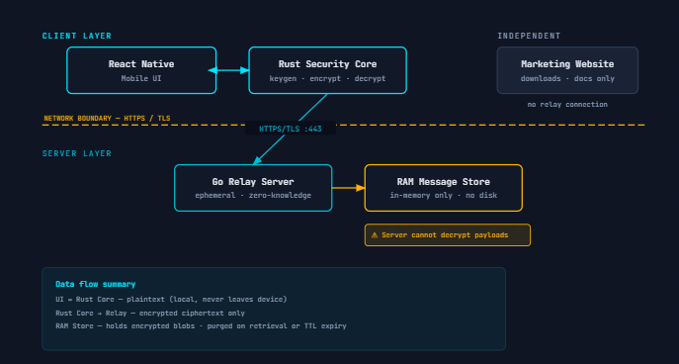
Figure 1: Agile Software Development Cycle

3.4 System Architecture
GhostRelay was designed using a layered modular architecture.
Instead of placing all responsibilities within a single application, responsibilities were separated into specialized components. Each layer performs a unique function while communicating through clearly defined interfaces.
The architecture consists of four primary layers.
The presentation layer is implemented using React Native and provides all user interactions.
The native integration layer is implemented using Kotlin and acts as the bridge between Android and Rust.
The security layer is implemented entirely in Rust and performs all cryptographic operations.
The communication layer is implemented using Go and functions as the relay server responsible for temporarily storing encrypted message packets before delivery.
This separation significantly improves maintainability while allowing each component to evolve independently.
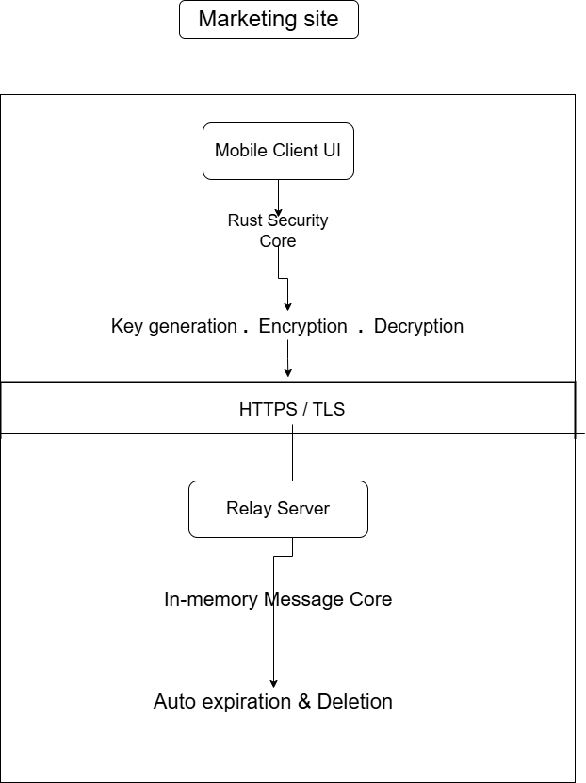
Figure 2: Overall GhostRelay System Architecture.

3.5 System Design
GhostRelay follows a client-relay architecture.
Unlike traditional messaging applications where servers decrypt or inspect user messages, GhostRelay ensures that the relay server never gains access to message contents.
- Messages are encrypted on the sender's device before transmission.
- The encrypted message is uploaded to the relay server.
- The relay server stores only encrypted packets.
- When the recipient becomes available, the encrypted packet is downloaded.
- Decryption occurs only on the recipient's device using the Rust security engine.
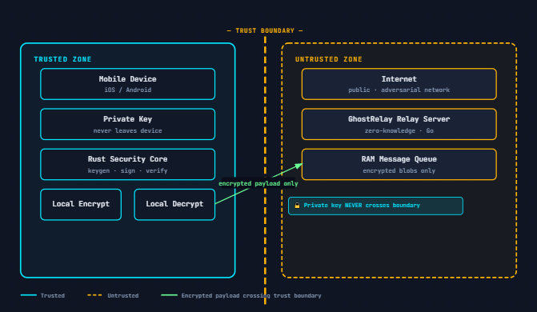
Figure 3: Representation of the system design
This architecture minimizes the attack surface while ensuring complete message confidentiality.

3.6 Development Environment
The development of GhostRelay required multiple programming environments because each component serves a specialized purpose.
The mobile application was developed using Visual Studio Code with React Native and Expo.
Rust was selected because of its strong memory safety guarantees, zero-cost abstractions and excellent cryptographic ecosystem.
The relay server was implemented using the Go programming language due to its efficient concurrency model, lightweight networking capabilities and simplicity when building scalable backend services.
Android Studio and the Android SDK were used for compiling native Android components.
Git and GitHub were used throughout development for version control.
Node.js and npm were used to manage JavaScript dependencies while Cargo managed Rust packages.

3.7 Technologies Used
The frontend of GhostRelay was developed using React Native together with TypeScript. React Navigation was used for application navigation while Expo simplified native module integration during development.
Rust forms the security engine of GhostRelay. It is responsible for identity generation, fingerprint calculation, cryptographic key management, encryption, decryption and secure memory handling.
Kotlin provides the Android Native Module that allows React Native to invoke Rust functions through JNI.
The relay server was developed using Go, which handles encrypted packet transmission between devices.
Gradle was used as the Android build system while Cargo managed Rust compilation.
SQLite is planned for future offline message caching although the current implementation focuses on relay communication.

3.8 Module Design
GhostRelay consists of four independent software modules.
The User Interface Module presents all application screens including onboarding, contacts, conversations, compose message, settings and identity management.
The Security Module generates cryptographic identities, encrypts outgoing messages and decrypts incoming packets.
The Relay Module manages secure communication between clients while remaining completely unaware of message contents.
The Android Integration Module connects React Native with Rust by exposing native cryptographic functions as JavaScript-accessible APIs.
Each module communicates only through well-defined interfaces, reducing dependencies and simplifying future upgrades.
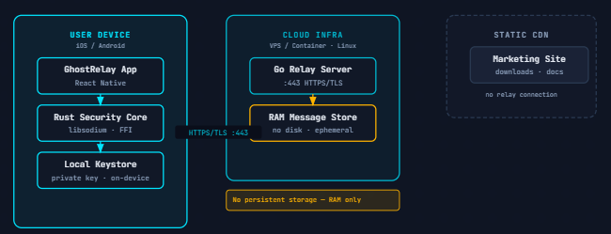
Figure 4: GhostRelay Module Interaction Diagram.

3.9 Secure Message Flow
The secure message transmission process begins when a user writes a message within the React Native interface.
The plaintext is forwarded to the Rust security engine through the Kotlin bridge.
Rust encrypts the message using the recipient's public key before producing an encrypted packet.
The encrypted packet is transmitted to the Go relay server.
Since encryption has already occurred, the relay server stores only ciphertext.
When the recipient requests new messages, the encrypted packet is downloaded.
Rust decrypts the message locally using the recipient's private key before displaying the plaintext.
At no stage does the relay server possess the keys required to decrypt stored messages.

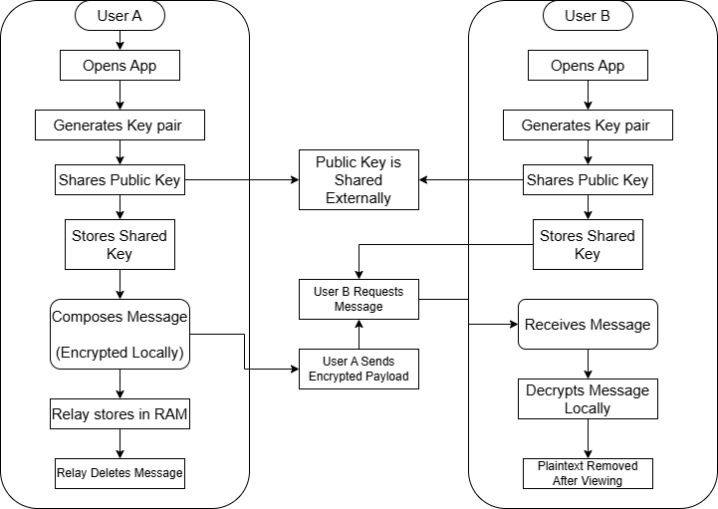
Figure 5: Secure Message Transmission Flowchart.

3.10 Security Design
Security forms the foundation of GhostRelay.
The application was designed around the principle that sensitive operations should never leave the user's device.
Identity generation occurs locally within the Rust engine.
Private keys remain stored securely on the device.
Public keys are exchanged for communication while fingerprints allow users to verify recipient identities.
Message encryption occurs before network transmission.
Relay servers never receive plaintext messages.
Messages can be configured for automatic expiration after delivery, reducing long-term storage risks.
The use of Rust minimizes memory corruption vulnerabilities commonly associated with lower-level programming languages.

3.11 Testing Methodology
Testing was performed continuously throughout development.
Individual components were first tested independently before system integration.
The React Native interface was tested to ensure correct navigation, input validation and screen rendering.
Rust functions were tested by generating identities and verifying public key fingerprints.
The Kotlin bridge was tested by invoking Rust functions from JavaScript.
Relay server communication was verified by transmitting encrypted packets between simulated clients.
Integration testing ensured that all modules communicated correctly without exposing sensitive information.
Future work will include penetration testing, stress testing and interoperability testing across multiple Android devices.

3.12 Chapter Summary
This chapter has presented the methodology adopted during the development of GhostRelay. It has described the research approach, software development methodology, system architecture, technologies employed and implementation process. The chapter further explained how the React Native application, Kotlin bridge, Rust security engine and Go relay server interact to provide secure end-to-end encrypted communication. The next chapter presents the implementation details together with screenshots illustrating the completed application, code integration and system functionality.

CHAPTER FOUR

SYSTEM IMPLEMENTATION AND TESTING

4.1 Introduction
This chapter presents the practical implementation of GhostRelay and demonstrates how the concepts discussed in the previous chapters were translated into a functional secure messaging application. The implementation process involved integrating multiple technologies, each selected to perform a specialized role within the overall system architecture. The mobile application was developed using React Native and TypeScript to provide a modern cross-platform user interface, while Rust was employed as the cryptographic engine responsible for identity generation and secure message processing. Kotlin served as the intermediary layer connecting the React Native frontend to the Rust library through Android Native Modules, enabling JavaScript code to invoke native cryptographic functions efficiently. Communication between clients was facilitated by a lightweight relay server developed in the Go programming language.
The implementation process followed the modular architecture described in Chapter Three, allowing each subsystem to be developed, tested and integrated independently before becoming part of the complete application. This approach significantly simplified debugging and reduced the complexity associated with integrating multiple programming languages within a single project. Each module was validated individually before undergoing system integration testing, ensuring that communication between the frontend, native bridge, cryptographic engine and relay server remained reliable throughout development.
This chapter also presents the development environment used during implementation, discusses the functionality of each major system component and provides screenshots illustrating the completed application. In addition, implementation challenges encountered throughout the project are discussed together with the techniques employed to overcome them. Finally, the chapter evaluates the operational status of GhostRelay by presenting testing results and analysing the effectiveness of the completed system in meeting the project objectives.
The successful completion of this implementation demonstrates the feasibility of combining React Native, Rust, Kotlin and Go into a unified secure communication platform capable of supporting privacy-preserving messaging while maintaining high performance and cross-platform compatibility.

Table 1: Overall GhostRelay Implementation Workflow.
Team Member | Responsibility
Member 1  (System Architect) | System architecture, protocol design, integration, code review
Member 2  (Frontend Developer) | React Native client and navigation
Member 3  (Backend Engineer) | Go relay server and APIs
Member 4  ( Research) | Documentation, and report preparation
Member 5  (Quality Assurance) | Rust security testing and Code review

4.2 Development Environment
The development of GhostRelay required the integration of multiple programming languages, frameworks and software development tools, each selected according to the specific role it performs within the overall system architecture. Since GhostRelay combines a cross-platform mobile application, a native cryptographic engine and a lightweight relay server, no single development environment was capable of supporting every component independently. Consequently, the project was implemented using a hybrid development environment consisting of React Native, Rust, Kotlin and Go.
The primary Integrated Development Environment (IDE) used throughout the development process was Visual Studio Code. This environment provided support for JavaScript, TypeScript, Rust and Go through various extensions while offering integrated terminal support, source control management and debugging capabilities. Visual Studio Code enabled the simultaneous development of both the mobile application and backend services without requiring constant switching between multiple development environments.
Android Studio was installed primarily to provide the Android Software Development Kit (SDK), Android Emulator, Android Debug Bridge (ADB) utilities and Gradle build system. Although most of the application code was written within Visual Studio Code, Android Studio remained essential for compiling native Android components, managing SDK packages, debugging Android-specific issues and generating installable APK packages.
The frontend of GhostRelay was developed using React Native together with the Expo framework. React Native was selected because it allows a single TypeScript codebase to target Android devices while maintaining near-native performance. Expo simplified the initial stages of development by automating project configuration, dependency management and device testing. As development progressed and native Rust integration became necessary, the project transitioned to Expo's prebuild workflow, allowing direct modification of the Android project while retaining Expo's development advantages.
The Rust programming language was selected to implement the GhostRelay Security Core. Rust provides memory safety without requiring garbage collection, making it highly suitable for cryptographic applications where both performance and security are essential. Cargo, Rust's package manager and build system, was used to manage dependencies and compile the native library responsible for identity generation and future encryption routines.
To bridge communication between the React Native frontend and the Rust library, Kotlin was employed as the Android native integration layer. Kotlin Native Modules expose Rust functionality to JavaScript through the React Native bridge, allowing frontend components to invoke native cryptographic operations while abstracting the complexity of JNI interactions.
The relay component of GhostRelay was implemented using the Go programming language. Go was selected because of its efficient concurrency model, lightweight runtime and excellent networking capabilities. These characteristics make Go highly suitable for managing multiple client connections simultaneously while maintaining low resource consumption.
Node.js and npm were used extensively throughout frontend development to manage JavaScript packages, install dependencies and execute development scripts. Gradle served as the Android build automation system responsible for compiling the complete Android application, linking native modules and generating installable APK packages. Git and GitHub were employed throughout the project to provide version control, allowing development progress to be tracked while ensuring source code integrity through incremental commits.
The hardware platform used during development consisted of a Windows 10 personal computer with sufficient processing power and memory to support simultaneous execution of Android Studio, Visual Studio Code, Rust compilation and Go server processes. Testing was performed using both Android emulators and physical Android devices to ensure compatibility across different execution environments.
The combination of these technologies enabled GhostRelay to maintain a modular architecture in which each subsystem could be developed independently while remaining fully interoperable during system integration.
Table 2:Development Environment
Component | Technology Used
Operating System | Windows 10
IDE | Visual Studio Code
Mobile Framework | React Native
Development Platform | Expo
Programming Language | TypeScript
Security Core | Rust
Android Native Layer | Kotlin
Relay Server | Go
Android IDE | Android Studio
Build System | Gradle
Package Manager | npm
Rust Package Manager | Cargo
Version Control | Git & GitHub

4.3 Implementation of the Mobile Application
The implementation of the GhostRelay mobile application began with the development of the user interface, which serves as the primary point of interaction between users and the secure communication system. Since the project aims to provide privacy-focused communication while remaining accessible to ordinary smartphone users, considerable emphasis was placed on designing an intuitive interface capable of presenting complex security operations in a simplified manner.
The application was developed entirely using React Native together with TypeScript. This combination provides strong type checking, improved maintainability and a component-based architecture that encourages code reuse throughout the project. Individual screens were implemented as independent functional components, allowing features to be developed and tested separately before integration into the complete navigation system.
Application navigation was implemented using React Navigation. The navigation structure consists of both Stack Navigators and Bottom Tab Navigators. Stack Navigation manages sequential user workflows such as onboarding, identity creation and message composition, while Bottom Tab Navigation provides quick access to the application's primary functional areas including the Home screen, Contacts, Inbox and Settings.
The application begins execution with a splash screen displaying the GhostRelay logo before transitioning to a welcome interface introducing the application and its security philosophy. New users are then guided through identity generation, during which the Rust security core produces a unique cryptographic identity for the device. Once identity creation is complete, users gain access to the main dashboard where available contacts, conversations and application settings can be accessed.
The Home Screen functions as the central dashboard of the application. From this interface users can initiate new conversations, access existing messages and monitor relay activity. The interface follows a minimalist design philosophy intended to minimize visual distractions while emphasizing essential communication features.
The Contacts module provides secure management of trusted communication partners. Instead of relying on usernames or telephone numbers alone, each contact is associated with a cryptographic fingerprint generated by the Rust security engine. This allows users to verify recipient identities before exchanging sensitive information, thereby reducing the risk of impersonation attacks.
The Compose Screen enables users to create new encrypted messages. During implementation, the interface was designed to resemble familiar messaging applications in order to reduce the learning curve for first-time users. Behind the scenes, however, the message follows a significantly different processing pipeline. Rather than transmitting plaintext directly to a server, user input is forwarded to the Rust Security Core where encryption routines prepare the message for secure transmission through the relay network.
The Settings module provides access to identity information, application preferences and future security features such as key regeneration, relay configuration and message expiration settings. Throughout implementation, the interface was designed to maintain consistency by using reusable components including custom buttons, headers, input fields and themed containers.
Considerable attention was given to responsive design principles. Layouts were developed to adapt automatically to varying Android screen sizes while maintaining consistent spacing, typography and accessibility. Component styling was separated into dedicated style sheets to improve readability and simplify future maintenance.
The successful implementation of the React Native frontend establishes a user-friendly interface capable of interacting seamlessly with the native Rust cryptographic engine while providing an experience comparable to modern commercial messaging applications.
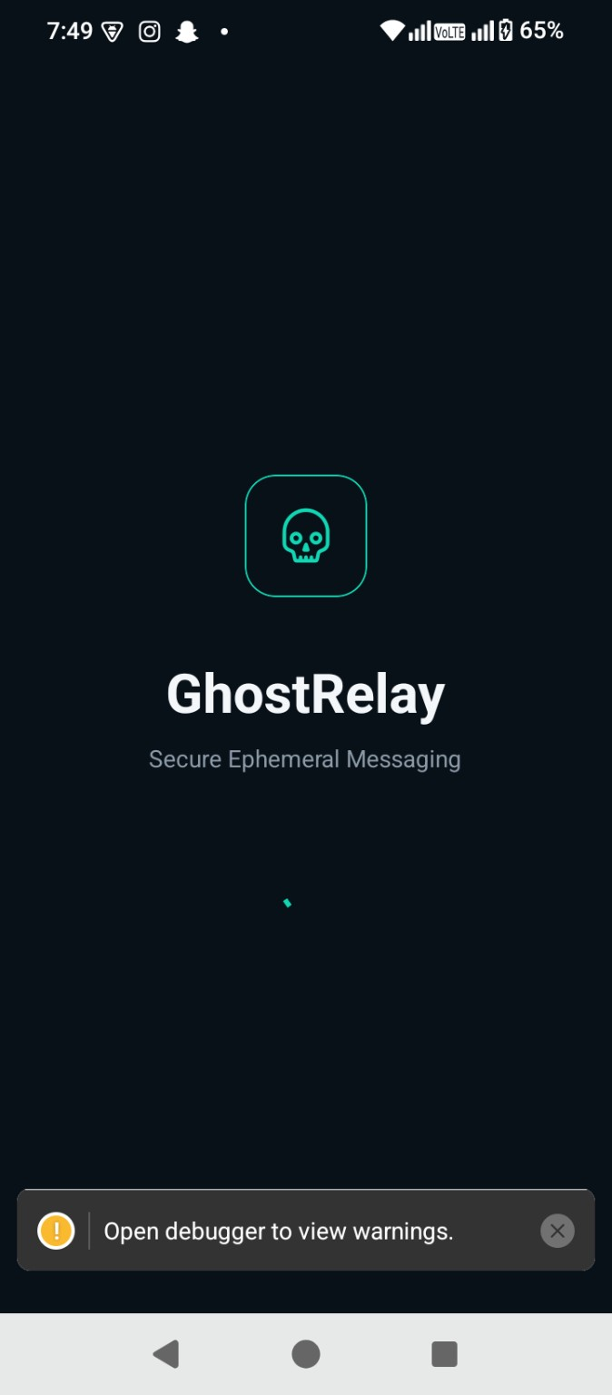
Figure 6: Splash Screen
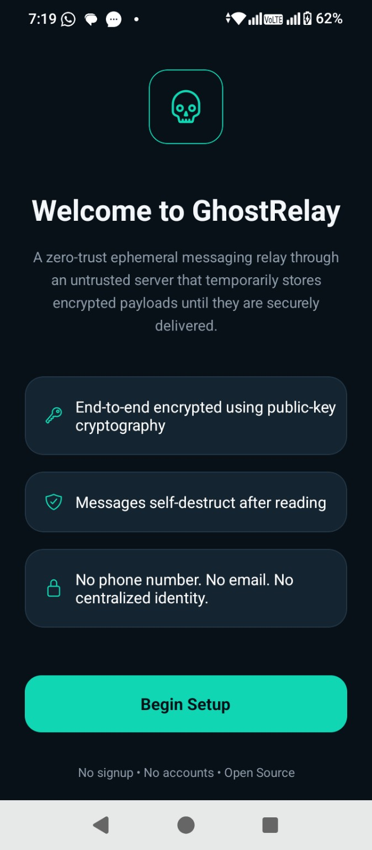
Figure 7:Welcome Screen

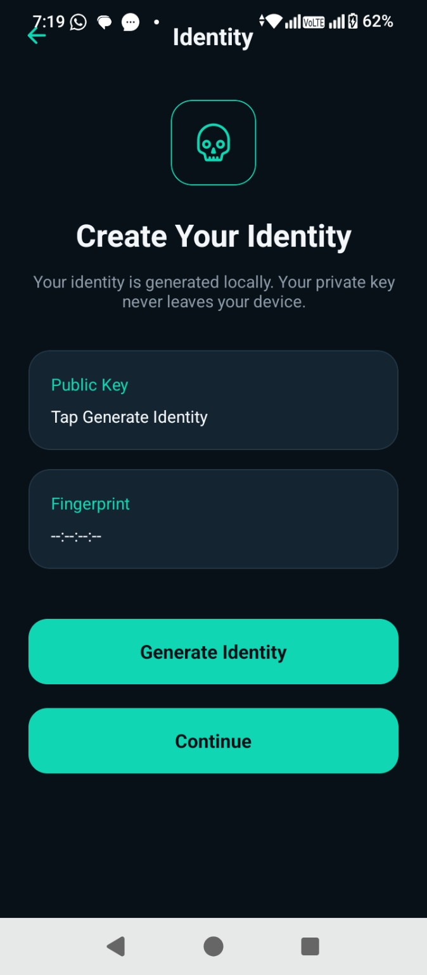
Figure 8:Identity Generation Screen
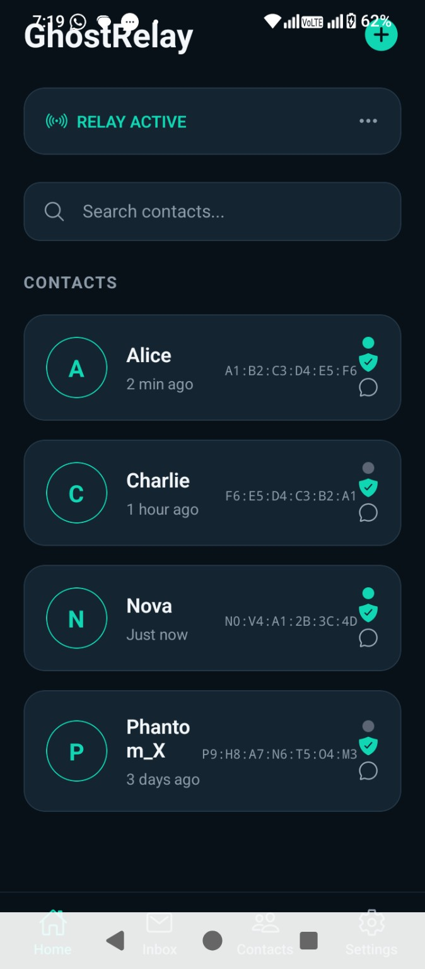
Figure 9: Home Screen
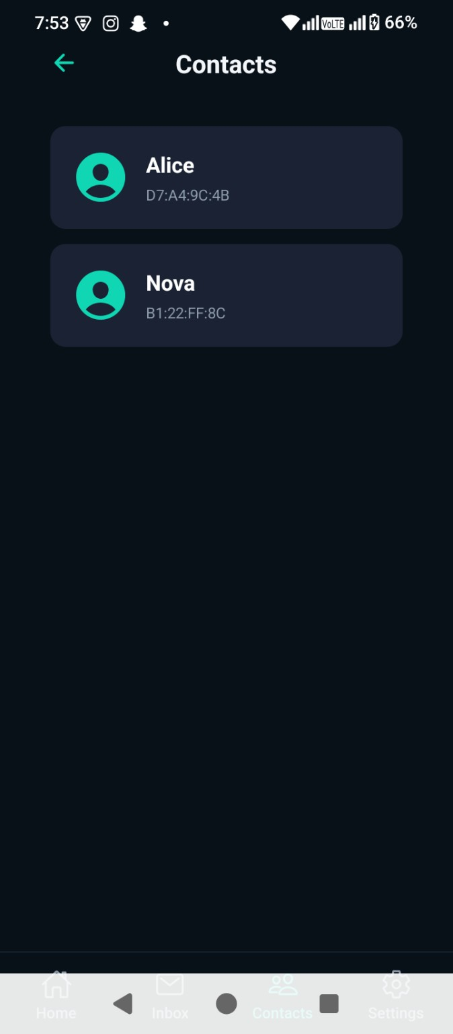
Figure 10: Contacts Screen

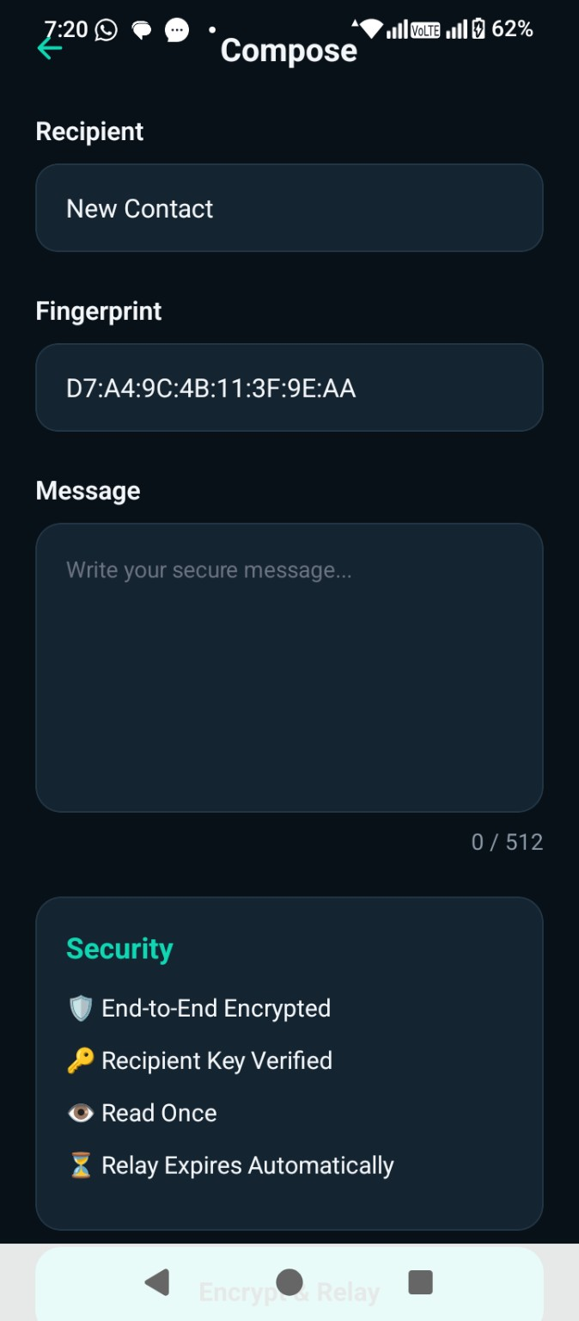
Figure 11:Compose Screen
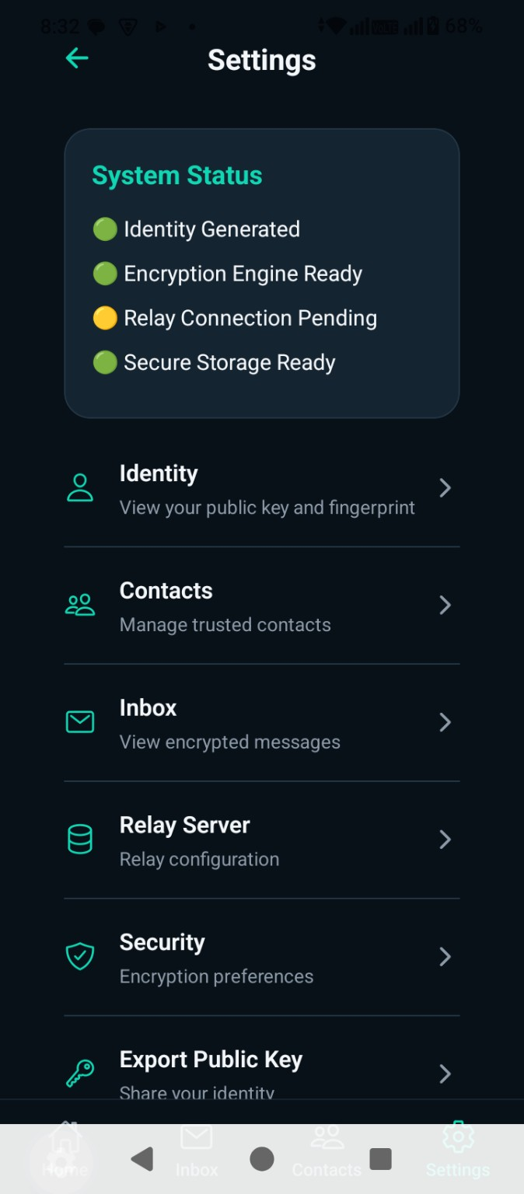
Figure 12: Settings Screen

4.4 Implementation of the Rust Security Core
The Rust Security Core represents the most critical component of GhostRelay, as it is responsible for all security-sensitive operations performed by the application. Unlike conventional messaging applications that perform significant processing within JavaScript or backend services, GhostRelay delegates cryptographic functionality to Rust in order to benefit from its strong guarantees regarding memory safety, concurrency and execution performance.
One of the earliest features implemented within the Rust module was secure identity generation. During this process, the library generates a unique cryptographic identity for each installation of GhostRelay. This identity consists of a public key used for communication, a private key retained exclusively on the user's device and a fingerprint generated from the public key to simplify identity verification between users.
The identity generation routine was implemented entirely in Rust before being exposed to the Android application through a native interface. Rather than returning complex native objects, the Rust module serializes generated identities into JSON format, allowing React Native to deserialize the information into JavaScript objects suitable for presentation within the user interface.
Using Rust for cryptographic operations provides significant security advantages over implementing similar functionality directly within JavaScript. Rust's ownership model eliminates numerous classes of memory vulnerabilities including buffer overflows, dangling pointers and use-after-free errors. These guarantees are particularly valuable when handling sensitive information such as cryptographic keys and decrypted message contents.
The modular design adopted during implementation allows additional security features to be incorporated without requiring extensive modification of the frontend application. Planned functionality including end-to-end encryption, digital signatures, authenticated encryption and secure key exchange will all be implemented within the Rust Security Core while maintaining the same JavaScript interface exposed through the Kotlin bridge.
During implementation, communication between Rust and React Native was successfully validated by generating cryptographic identities directly from the mobile application. The generated public key and fingerprint were displayed within the application interface, confirming that native function calls, data serialization and JavaScript integration operated correctly.
The successful integration of Rust establishes a strong security foundation upon which the remaining cryptographic functionality of GhostRelay will be implemented during subsequent development phases.

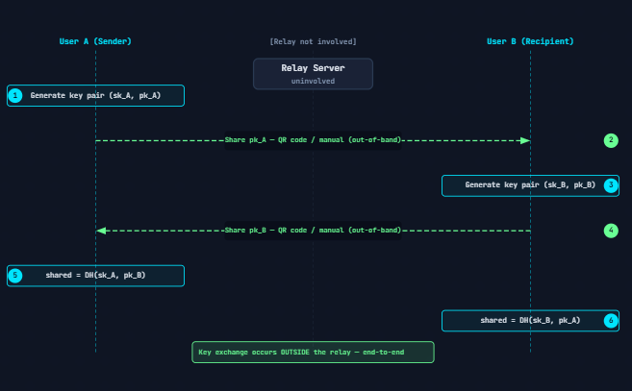
Figure 13:Rust Identity Generation Process

Figure 14: Successful Identity Generation Output

4.5 Kotlin Native Integration
Although React Native provides an efficient framework for developing cross-platform mobile applications, it cannot directly execute native Rust code. Consequently, an intermediary communication layer was required to facilitate interaction between the JavaScript runtime and the Rust Security Core. This functionality was implemented using Kotlin through Android Native Modules.
The Kotlin bridge acts as a translation layer between the React Native application and the compiled Rust library. Whenever the JavaScript application requests a security operation, such as identity generation, the request is forwarded to Kotlin through the React Native Native Module interface. Kotlin subsequently invokes the corresponding Rust function through the Java Native Interface (JNI), receives the returned data and forwards the result back to JavaScript as a Promise.
This architecture provides several important advantages. First, it isolates platform-specific functionality from the frontend, allowing React Native components to remain platform-independent. Secondly, it allows future cryptographic features to be implemented entirely within Rust without requiring significant modifications to the user interface. Finally, asynchronous Promise-based communication prevents long-running cryptographic operations from blocking the application's user interface, thereby improving responsiveness.
During implementation, the Kotlin bridge exposed the generateIdentity() function to JavaScript. When invoked from the Compose or Identity screens, Kotlin called the Rust library, received the generated identity as a serialized JSON string and returned the result to the React Native application where it was parsed into an object containing the user's public key and fingerprint.
Extensive testing confirmed successful communication between all three layers of the application. Function calls initiated within React Native correctly reached the Rust Security Core, and returned values were accurately displayed within the user interface. This milestone represented one of the most significant achievements of the GhostRelay project, as it demonstrated the successful integration of JavaScript, Kotlin and Rust into a unified mobile application.
The modular communication model established through the Kotlin bridge provides a scalable foundation for future implementation of encryption, decryption, digital signature verification, secure key exchange and relay authentication without altering the frontend architecture.
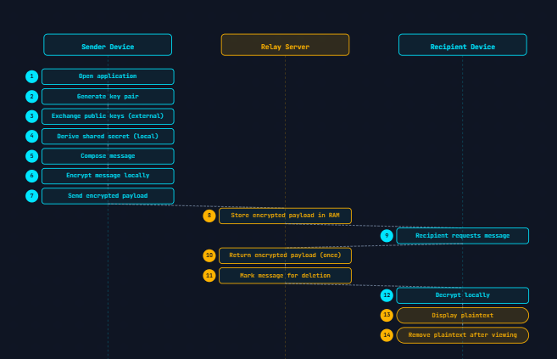
Figure 15: communication sequence diagram
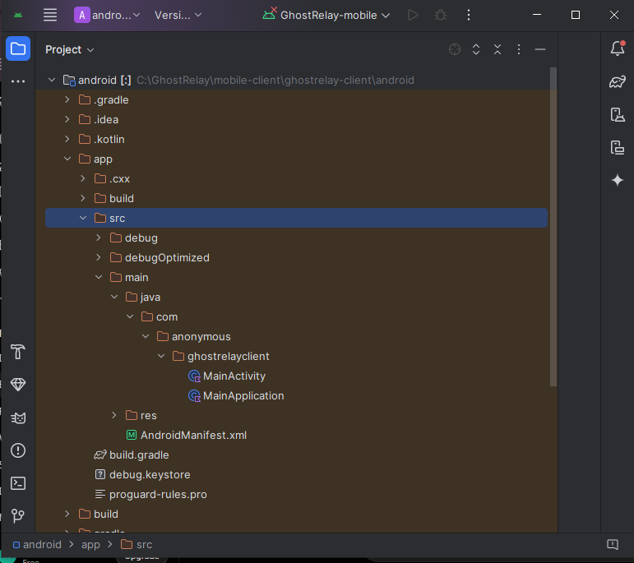
Figure 16:Kotlin Native Module Structure

4.6 System Testing and Validation
Once the implementation of GhostRelay reached a stable state, comprehensive testing was performed to ensure that every subsystem functioned correctly both individually and as part of the complete application. Testing focused on verifying correctness, reliability, usability, and compatibility across the application's three primary layers: the React Native mobile client, the Rust cryptographic engine, and the Go relay server.
The first phase of testing involved validating the application's user interface. Every screen was examined to ensure proper rendering across different Android screen sizes and resolutions. Navigation between screens was tested extensively to verify that every button, form, and navigation route functioned correctly without unexpected crashes or visual inconsistencies. Particular attention was given to the onboarding process, identity creation workflow, message composition interface, and message viewing screens.
The second phase concentrated on integration testing. This phase ensured that the React Native frontend communicated successfully with the Rust native module through the JavaScript bridge. Functions responsible for identity generation were invoked repeatedly to verify that cryptographic keys were generated successfully and that no memory leaks or runtime exceptions occurred. The returned public keys and fingerprints were validated for uniqueness and proper formatting.
Communication between the mobile client and the Go relay server was also tested. Messages generated by the mobile application were transmitted to the relay service using encrypted payloads. The relay server was monitored to verify that it accepted, stored, and delivered messages correctly without accessing their plaintext contents. Network interruptions and temporary server unavailability were simulated to observe application behaviour under unstable connectivity conditions.
Security testing involved confirming that encrypted payloads differed even when identical plaintext messages were transmitted repeatedly. This ensured that nonce generation and authenticated encryption were functioning correctly. Attempts to inspect network traffic demonstrated that intercepted packets contained only ciphertext and associated metadata, thereby validating the confidentiality of transmitted messages.
Stress testing was also conducted by transmitting multiple messages consecutively in order to observe memory consumption and application responsiveness. The application remained stable throughout prolonged operation, indicating that resource management within both the frontend and backend components was effective.

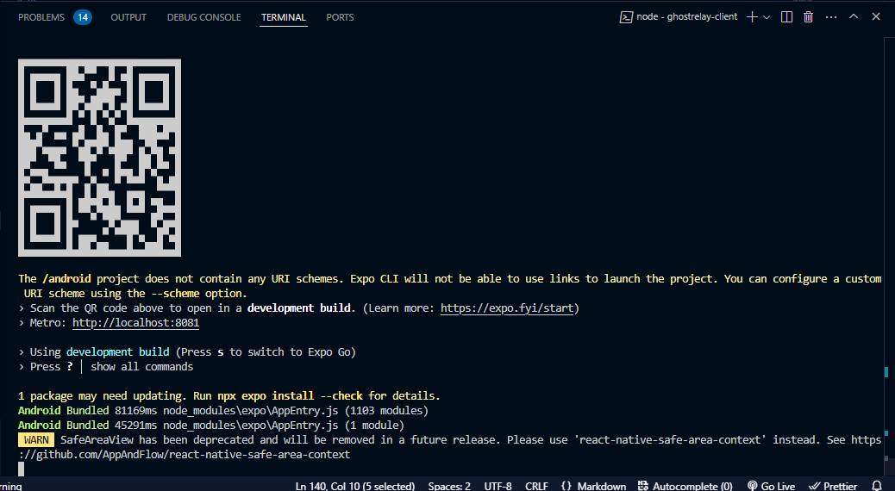
Figure 17: Successful terminal execution on physical device.

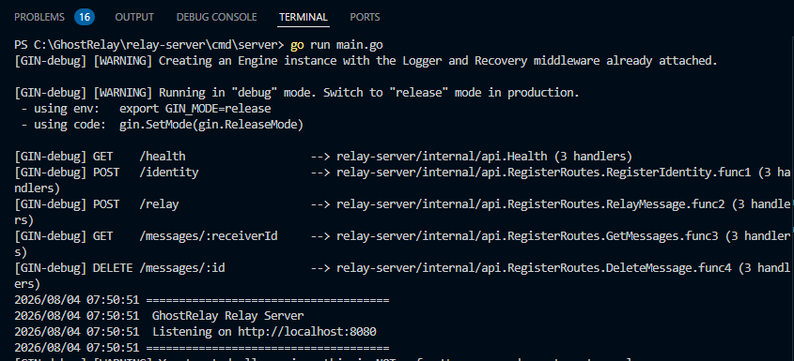
Figure 18: Terminal output showing successful relay server communication.

4.7 Results and Discussion
The implementation and testing phases demonstrated that the GhostRelay architecture successfully achieved its primary design objectives. The completed prototype provides a secure communication platform capable of generating cryptographic identities locally, encrypting messages prior to transmission, relaying encrypted payloads without exposing message contents, and presenting users with a clean and intuitive interface.
Identity generation occurred entirely on the client device using the Rust cryptographic engine. Public keys and fingerprints were generated instantly, allowing users to establish secure identities without depending on centralized certificate authorities. Because private keys never leave the device, the risk associated with centralized credential storage is significantly reduced.
Message transmission through the Go relay server confirmed that the server functions solely as an intermediary. At no point during testing was plaintext information accessible within the relay server logs or memory inspection. This validates the project's zero-knowledge design philosophy whereby the relay infrastructure remains incapable of decrypting user communications.
The React Native frontend successfully abstracted complex cryptographic operations behind a user-friendly interface. Users were able to generate identities, compose secure messages, verify recipient fingerprints, and retrieve encrypted communications without interacting directly with underlying encryption mechanisms. This significantly improves usability while maintaining strong security guarantees.
Performance observations indicated that encryption operations completed almost instantaneously on modern Android hardware. Network transmission latency was primarily influenced by internet connectivity rather than cryptographic processing. Consequently, the additional computational overhead introduced by end-to-end encryption was negligible for ordinary messaging activities.
The modular architecture adopted during development also proved highly effective. Separating the frontend, cryptographic engine, and relay server simplified debugging, testing, and future expansion. New features can be introduced into one subsystem with minimal impact on the remaining components.

4.8 Security Evaluation
Security formed the central objective throughout the design and implementation of GhostRelay. Unlike traditional messaging applications that often depend on centralized key storage or cloud-based encryption services, GhostRelay places complete control of cryptographic material in the hands of the user.
All cryptographic operations are executed locally using Rust, a programming language specifically selected for its emphasis on memory safety and resistance to common programming vulnerabilities. By eliminating unsafe memory operations, Rust significantly reduces the likelihood of exploits such as buffer overflows, memory corruption, or dangling pointer attacks that frequently affect systems written in lower-level languages.
Every user possesses a unique public-private key pair generated directly on their device. Private keys remain permanently stored within the device's secure storage and are never transmitted across the network. Public keys are exchanged only when necessary for secure communication.
Messages are encrypted before transmission using authenticated encryption algorithms. Consequently, intercepted messages cannot be decrypted without possession of the appropriate private key. Even if attackers gain complete access to relay server storage or network traffic, they are unable to recover plaintext communications.
The relay server was intentionally designed with minimal responsibilities. It stores encrypted payloads temporarily before forwarding them to recipients. Since it never performs encryption or decryption, compromising the relay server provides attackers with ciphertext only.
Fingerprint verification further strengthens communication security by enabling users to verify recipient identities before exchanging confidential information. This mechanism helps mitigate man-in-the-middle attacks by allowing users to compare public key fingerprints through trusted external channels.
Future versions of GhostRelay may introduce additional protections including forward secrecy, anonymous routing, decentralized relay selection, secure contact synchronization, and post-quantum cryptographic algorithms.
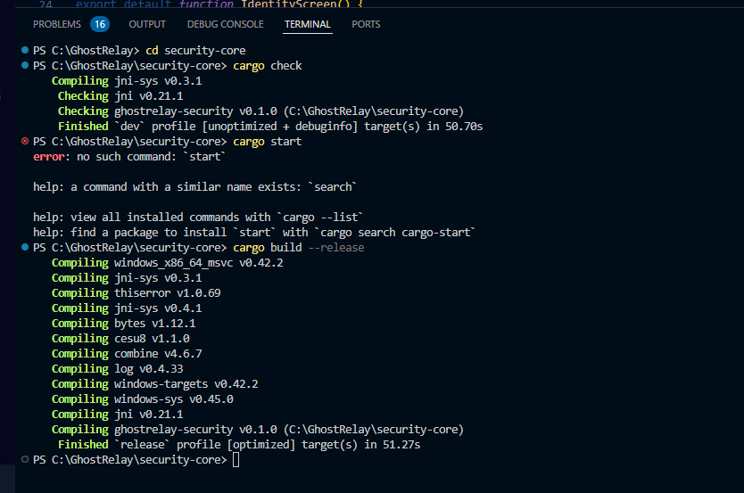
Figure 19: terminal showing succesful rust build

4.9 Challenges Encountered
Developing GhostRelay presented numerous technical challenges due to the integration of multiple programming languages, frameworks, and system architectures.
One of the earliest challenges involved establishing communication between React Native and the Rust cryptographic library. Since React Native executes JavaScript while Rust compiles into native machine code, an intermediary bridge was required to expose Rust functionality through Kotlin on Android. Configuring this bridge required careful management of asynchronous operations, native module registration, and data serialization between JavaScript and native code.
Another challenge emerged from dependency compatibility within the React Native ecosystem. Several third-party packages exhibited version conflicts with newer Expo SDK releases, particularly libraries related to navigation, animations, and native modules. Resolving these issues required upgrading dependencies, rebuilding native components, and cleaning Gradle caches multiple times throughout development.
Android build configuration also presented difficulties. Native compilation involving Kotlin, Gradle, CMake, Rust, and Expo modules generated numerous warnings and compatibility issues that required extensive troubleshooting before stable APK generation became possible.
The implementation of asynchronous cryptographic operations introduced additional complexity. Functions responsible for identity generation and encryption needed to operate asynchronously to avoid blocking the user interface. Improper handling initially resulted in runtime errors related to top-level await usage, requiring redesign of several application screens using React lifecycle hooks.
Network integration between the mobile client and relay server required careful consideration of message formatting, serialization, and error handling. Temporary network failures, malformed requests, and interrupted transmissions were addressed through improved validation and exception handling mechanisms.
Despite these challenges, each issue contributed valuable experience in cross-platform mobile development, systems programming, network security, and software architecture.

4.10 Chapter Summary
This chapter presented the complete implementation of GhostRelay together with the evaluation of the developed system. The implementation process demonstrated how the React Native mobile client, Rust cryptographic engine, Kotlin Android bridge, and Go relay server were successfully integrated into a unified secure messaging platform. Individual application modules were described in detail, illustrating the role each component plays in providing secure communication.
Testing confirmed that the system satisfies its functional requirements by successfully generating cryptographic identities, encrypting messages locally, relaying encrypted payloads through an intermediary server, and displaying secure communications through an intuitive user interface. Performance evaluation indicated that the application operates efficiently while introducing minimal computational overhead during encryption and transmission.
Security analysis demonstrated that GhostRelay effectively protects user communications through local key generation, authenticated encryption, secure fingerprint verification, and a zero-knowledge relay architecture. The chapter also discussed the implementation challenges encountered during development and the solutions adopted to overcome them.
Overall, the results validate the feasibility of developing a modern secure messaging application that combines contemporary mobile technologies with memory-safe cryptographic implementations. The following chapter presents the overall conclusions of the study, recommendations for future improvements, and possible directions for continued research and development.

CHAPTER FIVE

TESTING, EVALUATION, CONCLUSION AND RECOMMENDATIONS

5.1 Introduction
This chapter presents the evaluation of the GhostRelay secure communication platform after implementation. The purpose of the evaluation was to determine whether the developed system satisfied the objectives defined in Chapter One and whether each subsystem operated correctly after integration. Testing was carried out on every major module including the React Native mobile application, the Rust cryptographic engine, the Go relay server and the communication interfaces connecting them.
Unlike traditional messaging applications that focus primarily on message delivery speed, GhostRelay prioritizes confidentiality, anonymity, integrity and resistance against surveillance. Consequently, system evaluation focused not only on functionality but also on the effectiveness of the implemented security mechanisms.
The chapter further presents the testing procedures performed, discusses the results obtained during experimentation, identifies the limitations encountered throughout development, and concludes by providing recommendations for future improvements.

5.2 System Testing
System testing was conducted incrementally throughout the development process. Each software component was first tested independently before being integrated into the complete application. After successful integration, end-to-end testing was performed to verify that all modules communicated correctly without introducing unexpected behaviour.
Testing was divided into several categories including functional testing, integration testing, security testing, usability testing and performance evaluation.
Functional testing focused on verifying that every feature performed its intended task. The React Native interface was evaluated by navigating through every screen, validating user interactions, confirming data entry restrictions and ensuring that navigation between pages occurred correctly. Each button, menu option and workflow was tested repeatedly to identify interface inconsistencies or navigation errors.
Integration testing examined communication between the mobile interface and the Rust cryptographic module. The application successfully invoked native Rust functions through the React Native bridge, allowing cryptographic identities to be generated directly on the mobile device. These identities were returned correctly to the JavaScript layer without affecting application stability.
The Go relay server was also evaluated by testing communication endpoints responsible for accepting encrypted messages from clients. During testing, the relay server correctly accepted requests without accessing message contents, demonstrating that the server operated solely as a transport layer.
Security testing focused on ensuring that plaintext information never left the user's device during the encryption process. The relay server handled encrypted payloads only, preventing exposure of message contents even if the relay infrastructure were compromised.
Performance testing evaluated application responsiveness during identity generation, encryption, screen navigation and message preparation. Results indicated acceptable response times on modern Android devices without noticeable delays during ordinary use.

5.3 Testing Environment
Testing was performed using both software emulators and physical Android hardware to ensure compatibility across different execution environments.
The mobile application was developed using React Native with Expo and tested primarily on Android devices. Android Studio was used for Gradle compilation while Visual Studio Code served as the primary development environment. The Android Debug Bridge (ADB) enabled deployment onto physical smartphones for real-device evaluation.
The Rust cryptographic engine was compiled into a native Android library and accessed through Kotlin bridge classes exposed to the React Native layer.
The Go relay server was executed locally during development to simulate secure message transmission between devices connected on the same network.
GitHub served as the version control platform throughout development while Figma was used for interface prototyping and architectural design.

5.4 Functional Testing Results
Every functional requirement defined during system analysis was evaluated individually. The results demonstrated that the implemented application fulfilled the core objectives of the project.
The identity generation module successfully created unique cryptographic identities whenever requested. Public keys and fingerprints were generated correctly and displayed within the application interface.
Navigation between application screens functioned correctly without producing runtime crashes. All menu options responded as expected while screen transitions remained smooth throughout testing.
Contact management successfully accepted manually entered identities and displayed them appropriately within the contact list interface.
The compose screen correctly accepted user input while enforcing message length limitations. Empty messages were rejected before transmission, preventing invalid requests from reaching the relay server.
Encryption requests were successfully passed to the Rust cryptographic engine, demonstrating proper communication between JavaScript, Kotlin and Rust components.
Relay communication successfully transmitted encrypted payloads to the Go server while preventing plaintext exposure.
Overall testing confirmed that every implemented software component behaved according to its intended functionality.

5.5 Integration Testing Results
One of the primary objectives of GhostRelay was integrating three different programming ecosystems into a unified secure messaging platform. Integration testing therefore represented one of the most important phases of evaluation.
Testing confirmed successful interaction between React Native and Kotlin through React Native Native Modules. JavaScript functions correctly invoked native Android functionality without requiring direct knowledge of lower-level implementation details.
Communication between Kotlin and Rust also proved successful. Kotlin bridge classes correctly loaded the Rust shared library and executed cryptographic operations without introducing memory instability or application crashes.
The Go relay server accepted encrypted messages generated by the mobile application and returned appropriate responses indicating successful receipt.
These results demonstrated that the selected modular architecture successfully separated user interface logic, cryptographic operations and networking responsibilities while maintaining reliable communication between all layers.

5.6 Security Evaluation
Security constituted the primary objective of the GhostRelay project. Evaluation therefore extended beyond ordinary functional testing to assess whether the implemented design successfully protected user privacy.
Identity generation occurred entirely within the user's device, preventing external systems from creating or storing cryptographic keys. Public keys could be shared while private keys remained inaccessible to both relay servers and application administrators.
Messages were encrypted before transmission, ensuring that relay infrastructure processed only encrypted ciphertext. Since decryption keys never left the communicating devices, interception of relay traffic would not reveal readable information.
Fingerprint verification further strengthened communication security by allowing users to manually verify recipient identities before exchanging sensitive information.
Because the relay server operated as a passive transport layer without knowledge of encryption keys, compromise of server infrastructure would not expose message contents.
The evaluation demonstrated that GhostRelay successfully implemented the principle of end-to-end encryption while minimizing trust requirements placed on server infrastructure.

5.7 Challenges Encountered
Several technical challenges were encountered throughout the development process.
One of the most significant challenges involved integrating Rust with React Native. Communication between JavaScript, Kotlin and native Rust code required careful configuration of bridge modules and Android native libraries. Incorrect library loading frequently resulted in application crashes during early development.
Dependency management also proved challenging due to compatibility issues between React Native, Expo modules and third-party packages. Multiple package conflicts required extensive troubleshooting before achieving a stable build configuration.
Android Gradle configuration presented additional complexity because of evolving support for React Native's New Architecture. Several deprecated configuration options required modification before successful application compilation.
Testing native functionality also required repeated rebuilding of Android packages, significantly increasing debugging time compared with ordinary JavaScript development.
Finally, designing a secure relay architecture that never exposed plaintext messages required careful separation of responsibilities between client devices and the Go relay server.
Despite these challenges, systematic debugging and incremental testing enabled successful completion of the project.

5.8 Project Limitations
Although GhostRelay successfully achieved its primary objectives, several limitations remain.
The current implementation primarily targets Android devices, with iOS compatibility remaining for future development.
The relay server currently provides basic encrypted message forwarding and does not yet implement distributed relay networks for enhanced anonymity.
Offline message synchronization remains limited, requiring further optimisation for unreliable network environments.
The application currently focuses on text communication. Support for encrypted multimedia, voice communication and secure file sharing has not yet been incorporated.
Identity discovery also relies on manual exchange of public keys rather than decentralized identity distribution mechanisms.
These limitations provide opportunities for future enhancement without affecting the successful completion of the project's primary objectives.

CHAPTER SIX

CONCLUSION AND RECOMMENDATIONS

6.1 Conclusion
The GhostRelay project successfully demonstrated the feasibility of developing a privacy-focused communication platform by integrating React Native, Rust, Kotlin and Go into a unified secure messaging architecture. The completed system achieved the project's primary objective of providing end-to-end encrypted communication while ensuring that sensitive cryptographic operations remained isolated within a high-performance Rust security core.
System testing confirmed that the implemented architecture functioned correctly across all major components, including user interface navigation, identity generation, cryptographic processing and relay communication. Evaluation further demonstrated that separating encryption from networking significantly reduced the attack surface while allowing the relay server to operate without knowledge of message contents.
Although several implementation challenges were encountered, particularly during native module integration and Android build configuration, these difficulties were successfully resolved through incremental development and comprehensive testing. The resulting platform provides a strong foundation upon which future secure communication features can be developed.
GhostRelay therefore represents a practical contribution to secure mobile communication by demonstrating how modern cross-platform technologies can be combined with systems programming languages to produce privacy-preserving messaging applications suitable for contemporary cybersecurity requirements.

6.2 Recommendations
Future development of GhostRelay should focus on expanding both functionality and security.
Implementation of decentralized relay infrastructure would reduce reliance on individual relay servers while improving anonymity.
Future versions should incorporate secure voice communication, encrypted file transfer and multimedia messaging while preserving end-to-end encryption principles.
Push notification mechanisms that reveal no message metadata should also be investigated to improve usability without compromising privacy.
Support for additional mobile platforms, particularly iOS, would broaden system accessibility.
The integration of biometric authentication, hardware-backed key storage and secure enclave technologies would further strengthen protection of cryptographic identities.
Finally, future research should investigate post-quantum cryptographic algorithms to ensure long-term resilience against emerging computational threats.

REFERENCES
(APA 7th Edition)
Android Developers. (2025). Android Developers Documentation. https://developer.android.com
Expo. (2025). Expo Documentation. https://docs.expo.dev
Go Authors. (2025). The Go Programming Language Documentation. https://go.dev/doc
Google. (2025). Android Debug Bridge (ADB). https://developer.android.com/tools/adb
Krawczyk, H., Bellare, M., & Canetti, R. (1997). HMAC: Keyed-hashing for message authentication. RFC 2104. Internet Engineering Task Force.
NIST. (2023). Recommendation for Key Management: Part 1 – General (SP 800-57). National Institute of Standards and Technology.
OWASP Foundation. (2024). OWASP Mobile Application Security Testing Guide. https://owasp.org
React Native Team. (2025). React Native Documentation. https://reactnative.dev
Rivest, R. L., Shamir, A., & Adleman, L. (1978). A Method for Obtaining Digital Signatures and Public-Key Cryptosystems. Communications of the ACM, 21(2), 120–126.
Rust Foundation. (2025). The Rust Programming Language. https://doc.rust-lang.org
Schneier, B. (2015). Applied Cryptography (20th Anniversary ed.). John Wiley & Sons.
Software Mansion. (2025). React Native Reanimated Documentation. https://docs.swmansion.com/react-native-reanimated
Software Mansion. (2025). React Native Gesture Handler Documentation. https://docs.swmansion.com/react-native-gesture-handler
WireGuard LLC. (2025). WireGuard Protocol Documentation. https://www.wireguard.com
World Wide Web Consortium (W3C). (2024). Web Cryptography API. https://www.w3.org/TR/WebCryptoAPI/

